**Experiment Number:** ***8*** **Date**: 29/03/2011

**Buck-Boost Converter using IGBT**

**Aim:**

To simulate the circuit of a buck-boost converter using IGBT and verify its operation using MATLAB and Simulink.

**Components Required:**

The following components are required from the Simulink block-sets:

|  |  |  |  |
| --- | --- | --- | --- |
| **S.No.** | **Component** | **No.** | **Specification** |
| 1. | DC Voltage Source | 1 | 100V |
| 2. | IGBT | 1 | - |
| 3. | Capacitor | 1 | 10µF |
| 4. | Inductor | 1 | 0.45mH |
| 5. | Diode | 1 | - |
| 6. | Series RL Load | 1 | - |
| 7. | Measuring Scope | 1 | - |
| 8. | Pulse Generator | 1 | - |

**Description:**

A buck-boost regulator provides an output voltage that may be less than or greater than the input voltage-hence the name “buck-boost”; the output voltage polarity is opposite to that of the input voltage. This regulator is also known as an inverting regulator. The main application of a step-up/step-down or buck-boost converter is in regulated dc power supplies, where a negative polarity output may be desired with respect to the common terminal of the input voltage, and the output voltage can be either higher or lower than the input voltage.

A buck-boost converter can be obtained by the cascade connection of the two basic converters: the step-down converter and the step-up converter. In steady state, the output-to-input voltage conversion ratio is the product of the conversion ratios of the two converters in cascade (assuming the switches in both converters have the same duty ratio).

**Formula:**

$$Vo= -\frac{δ}{1-δ} Vin$$

**Circuit Diagram:**

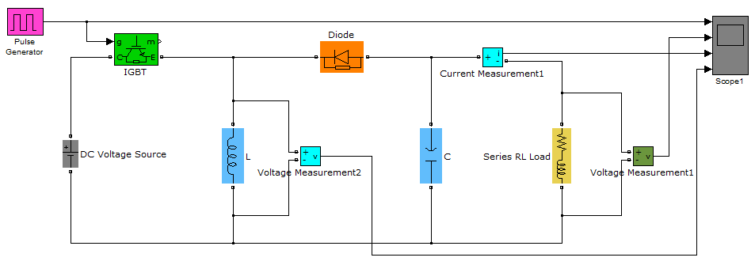

**Working:**

The circuit operation can be divided into modes. During mode 1, the IGBT is turned on and the diode is reverse biased. The input current which rises, flows through inductor L and IGBT. During mode 2, the IGBT is switched off and the current which was flowing through inductor L, would flow through L, C, diode and the load. The energy stored in inductor L would be transferred to the load and the inductor current would fall until IGBT is switched on again in the next cycle.

A buck-boost regulator provides output voltage polarity reversal without a transformer. It has high efficiency. Under a fault condition of the IGBT the *di/dt* of the fault current is limited by the inductor L. The disadvantage of this circuit is that the input current is discontinuous and a high peak current flows through IGBT.

**Output Waveforms:**

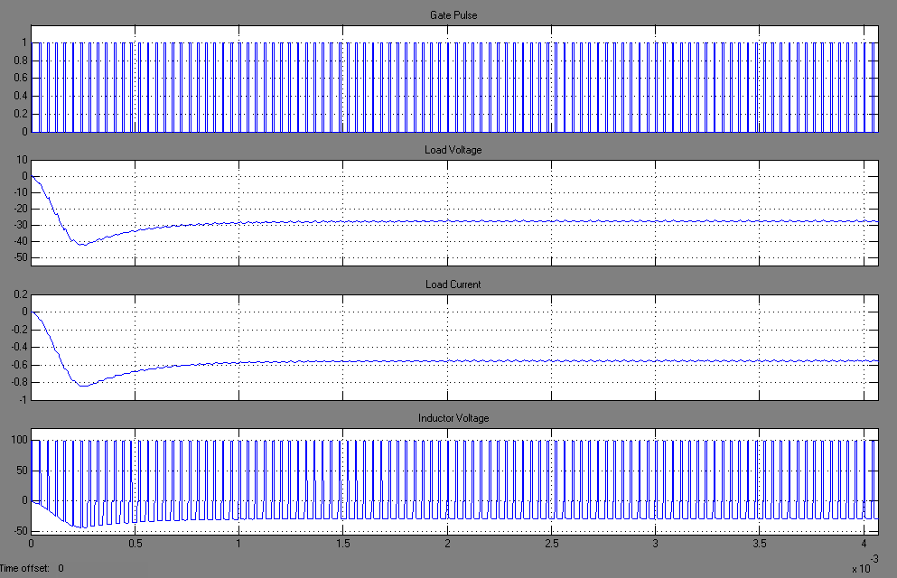The various waveforms obtained after the simulation of the circuit are shown below. They include gate pulse to *IGBT*, voltage across the inductor, load and the load current.

1. *Buck Operation* (δ = 0.2 )
2. *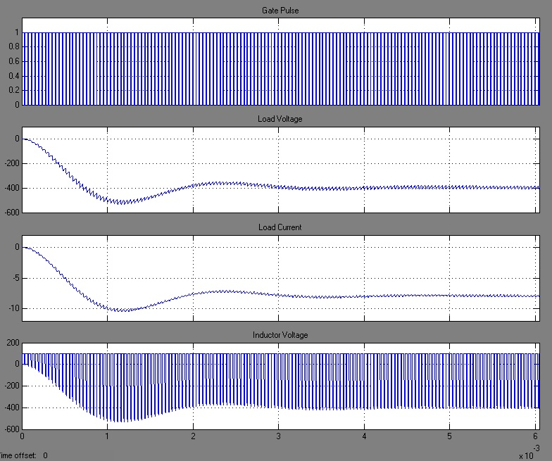Boost Operation* (δ = 0.8 )

**Result:**

|  |  |  |  |
| --- | --- | --- | --- |
| **Simulation and Report** by,  Sambhav R Jain  S Vignesh  Anup Srivatsan  S P Jainaveen |  | Marks | Signature |
| Simulation |  |  |
| Output |  |  |
| Report |  |  |

Hence the operation of a buck-boost converter using an IGBT is simulated and its working is validated by observing the respective output waveforms.